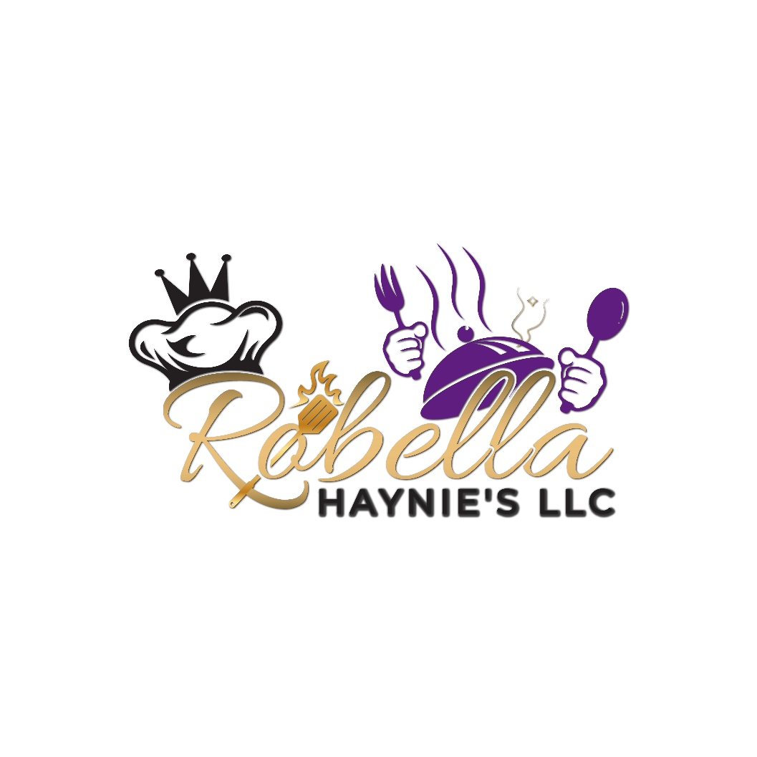

Flint, MI 48507
(810) 813-1809

Brunch Menu  $30 per person**  Select one dish from each course | First Course  Avocado Toast  Grilled toast, avocado spread, pickled onion, roasted tomato, microgreens, fried egg  Arugula Salad  Tomato, arugula, parmesan, lemon garlic vinaigrette  Peach Cobbler Smoothie Bowl  Roasted peaches, fresh berries, Greek vanilla yogurt, granola, sweet bourbon honey  Second course  Chicken and Cornbread Pancakes  Crispy fried chicken, fluffy sweet potato cornbread pancake honey butter, pepper sauce  Shrimp and Grits  Cheddar parmesan grits, seared shrimp, bacon, microgreens Cajun garlic butter,  Skirt Steak  Marinated skirt steak, wild mushroom risotto, chimichurri, parmesan cheese  Boo-kiddie Turkey Wing Lo Mein  Breaded turkey wing, boo-kiddie sauce, stir fried noodles and vegetables, toasted sesame seeds, grilled onion.  Third course  Vanilla Cheesecake  Toppings: Strawberry, sauteed peaches, black cherry, extra crust  Mousse Flight  Espresso, citrus, berry , caramel cookie  Seared Pound Cake  Vanilla mousse, berries  Additions: Salmon/ skirt steak/ shrimp/ crispy chicken/ bacon/ egg  Garlic green beans/ Lemon asparagus/ Roasted tomatoes

Breakfast Menu

Breakfast Packages
- Basic BREAKy - $11
Includes bacon or savory sausage, scrambled eggs, breakfast potatoes prepared your way, sliced fresh fruit, assorted fruit juices, bottled water, and tea.

- Mini Me BREAKy - $13
Features bacon, egg, and cheese sliders, mini hash brown bites, fresh sliced fruit, assorted fruit juices, bottled water, and tea.

- Frenchy BREAKy - $16
Offers cinnamon French toast with powdered sugar, scrambled eggs, crispy bacon or savory sausage, breakfast potatoes, fresh sliced fruit, a selection of chilled juice, bottled water, and tea.

- Royalty BREAKy - $22
Savor garlic shrimp and grits, waffles with berry topping, crispy scrambled eggs, fresh sliced fruit, chilled juice, bottled water, and tea.

BREAKy A La Carte
- Whole Fresh Fruit - $2 each
- Croissants - $15 per dozen
- Coffee Cake Slices - $18 per dozen
- Assorted Donuts - $20 per dozen
- Assorted Muffins & Danish - $15 per dozen
- Freshly Baked Cinnamon Rolls - $15 per dozen
- Assorted Bagels with Cream Cheese - $15 per dozen
- Fresh Sliced Fruit Platter (serves 12) - $40 each
- Quiche - $4 each
- Biscuits and Sausage Gravy - $5 each
- Frittata - $5 each
- Bacon - $3 each
- Sausage - $3 each
- Hash Browns - $2 each
- Scrambled Eggs - $3 each
- Fruit, Yogurt Granola Parfait - $5 each
- Waffle and Berries - $10 per dozen
- Shrimp and Grits - $10 each
- Oatmeal or Grits - $2 each

Create Your Own Buffet
- $15 per person
Choice of 1 entrée, 2 sides, assorted dinner rolls with butter, and dessert.

- $25 per person
Choice of 2 entrées, 2 sides, assorted dinner rolls with butter, and dessert.

- $35 per person
- Choice of 3 entrées, 3 sides, assorted dinner rolls with whipped butter, and dessert.

Entrée Selections
- Barbeque Pulled Pork
- Seared Salmon with Tea Glaze
- Garlic and Herb Roasted Beef
- Citrus Grilled Chicken
- Southern Fried Chicken
- Pan Seared Cod
- Vegetable Lasagna
- Pasta Primavera
- Apple Glazed Pork Loin
- Shrimp Scampi
- Braised Beef
- Eggplant Parmesan

Salad Options
- House - $2
- Italian Pasta - $2
- Harvest - $3
- Spinach - $3
- Caesar - $3
- Coleslaw - $2
- Creamy Potato - $2
- Caprese - $4

Vegetable Sides ($3 per person)
- Steamed Broccoli
- Medley of Vegetables
- Garlic Green Beans
- Grilled Asparagus
- Sautéed Zucchini and Squash
- Glazed Baby Carrots
- Cauliflower Rice

A La Carte Starch Sides ($4 per person)
- Quinoa Pilaf
- Rice Pilaf
- Red Beans and Rice
- Mushroom Parmesan Risotto (extra charge)
- Glazed Sweet Potato Mash
- Buttery Potato Mash
- Homemade Macaroni and Cheese
- Herb Roasted Red Potato
- Northern Beans and Greens

Appetizers
- $50 for 25 pieces
- $100 for 50 pieces
- $200 for 100 pieces
- Antipasto Skewers
- Tomato-Basil Bruschetta on Crostini
- Cheeseburger Sliders
- Mini Tuna Tacos
- Mini Chicken Quesadillas
- Mini Crab Cakes with Chipotle Aioli
- Cherry Tomato, Basil and Mozzarella Skewers
- Boursin Stuffed Zucchini
- Stuffed Button Mushrooms
- Chicken Skewers with Peanut Sauce
- Shrimp Cocktail

Platters
- Artisan Cheese and Cracker Display - $5 per person
- Gourmet Vegetable Crudités with Dip - $3 per person
- Fresh Seasonal Fruit and Berries - $5 per person

Chef Attended Action Stations (per person + attendant fee)
- Pasta Station - $15
- Mac Bar - $15
- Stir-Fry Station - $15
- Nacho Bar - $12
- Waffle Station - $12
- Omelet Station - $13

